**Finding Minimum and Maximum Values in an Array**

**Objective:**

To write a C program to find the minimum and maximum values in an array of integers.

**Theory:**

**Algorithm:**

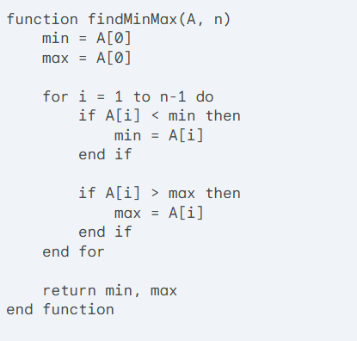

**C Implementation:**

#include <stdio.h>

void maxValue(int ar[], int n)

{

  int mx = ar[0];

  for (int i = 1; i < n; i++)

  {

    if (ar[i] > mx)

    {

      mx = ar[i];

    }

  }

  printf("Maximum value = %d\n", mx);

}

void minvalue(int ar[],int n)

{

  int mn = ar[0];

  for (int i = 1; i < n; i++)

  {

    if (ar[i] < mn)

    {

      mn = ar[i];

    }

  }

  printf("Minimum value = %d\n", mn);

}

int main()

{

  int n;

  printf("Enter Array Size = ");

  scanf("%d", &n);

  int ar[n];

  printf("Enter array Element\n");

  for (int i = 0; i < n; i++)

  {

    scanf("%d", &ar[i]);

  }

  maxValue(ar, n);

  minvalue(ar, n);

}

**Time and Space Complexity:**

* **Time Complexity:** O(n)
  + The algorithm iterates through the array once, making a constant number of comparisons and assignments for each element.
* **Space Complexity:** O(1)
  + The algorithm uses a constant amount of extra space for the min, max, and loop counter variables.